Invention Disclosure Format (IDF)-B | Document No. 02-IPR-R003
Vellore Institute of Technology | Issue No/Date: 2 / 01.02.2024
(Deemed to be University under section 3 of UGC Act, 1956) | Amd. No/Date: 0 / 00.00.0000

1. Title of the invention:
A Provenance-Aware, Cycle-Safe, Multi-Generation Per-Pixel Source and Synthetic Share Propagation System and Control Algorithm for Satellite Image Reconstruction
(Project name: OrbitalTrace — Provenance-Aware Satellite Image Reconstruction)
2. Field /Area of invention:
- Spatially resolved per-pixel data provenance and lineage control
- Multi-generation directed acyclic graph (DAG) weight propagation algorithms
- Cryptographic hash-chained image authenticity verification
- Deterministic pipeline gating and generative hallucination control
- Remote sensing and satellite image super-resolution
3. Prior Patents and Publications from literature (summary of prior art):
Sr. No. | Patent / Publication (IEEE Format) | Description | Relevance to Your Invention
1 | B. Wronski et al., “Handheld Multi-Frame Super-Resolution,” ACM Trans. Graph., vol. 38, no. 4, Art. 28, Jul. 2019. | Merges a burst of raw frames using per-pixel anisotropic Gaussian kernel weights (w_{n,i}) and a motion robustness mask (R̂_{n}). | Computes per-pixel frame weights during a single merge step, but discards weights after normalization; lacks persistent per-pixel provenance layers, multi-generation DAG propagation, or inherited synthetic share tracking.
2 | J. Brandt et al. (Adobe Inc.), “Tracking Changes to Electronic Documents via a Decentralized Ledger,” US Patent 11,146,381 B2, Oct. 19, 2021. | Links sequential document edit states using cryptographic fingerprints in a ledger to trace editing history. | Whole-document hash-chained edit history only; does not compute per-pixel sensor frame contribution vectors, 3-state pixel class maps, or compounding synthetic shares across passes.
3 | D. Muff (Iceye Oy), “Generating Synthetic Aperture Radar Image Data,” European Patent Application EP 4,530,673 A1, Apr. 2, 2025. | Pre-computes per-pixel amplitude (√(I²+Q²)) and phase (tan⁻¹(Q/I)) data bands in a GeoTIFF container from raw SAR signals. | Single-pass SAR signal-to-GeoTIFF formatting; lacks multi-generation super-resolution refinement tracking, per-pixel source weight propagation, or hash-linked DAG verification.
4 | T. J. Green, G. Karvounarakis, and V. Tannen, “Provenance Semirings,” in Proc. ACM SIGMOD-SIGACT-SIGART Symp. Principles of Database Systems (PODS), 2007, pp. 31–40. | Algebraic framework for propagating annotations/weights through relational database queries (join/project/union). | Relational database tuple algebra only; does not handle spatial raster alignment, cloud-occlusion pixel masks, 3-state pixel classification (OBSERVED, WEAK, SYNTHESIZED), or generative contamination compounding.
5 | Coalition for Content Provenance and Authenticity (C2PA), “C2PA Technical Specification,” v2.1, 2024, and J. Wu et al., “When the Forger Is the Judge,” arXiv, Apr. 2026. | Signed manifest attestations for media files (C2PA) and forensic evaluation of AI-edited document masks (Wu et al.). | File-level or static action-region manifests; lacks quantitative per-pixel raw-sensor share propagation across multi-pass super-resolution DAGs and PSNR/SSIM regression gating.
6 | D. Jiang and J. Shen (PayPal, Inc.), “Graphical User Interface to Depict Data Lineage Information in Levels,” US Patent 12,645,655 B2, Jun. 2, 2026, and M. Demazeau et al. (Amadeus S.A.S.), EP 4,478,216 A1, Dec. 2024. | Enterprise database lineage tracking via metadata identifiers/dummy values and multi-level upstream/downstream GUI panels. | Coarse enterprise database table/node lineage; lacks image processing, per-pixel uncertainty/source layers, or continuous sensor weight composition.

References:
- B. Wronski et al., “Handheld Multi-Frame Super-Resolution,” ACM Trans. Graph., vol. 38, no. 4, Art. 28, Jul. 2019.
- J. Brandt et al., “Tracking Changes to Electronic Documents via a Decentralized Ledger,” US Patent 11,146,381 B2, Oct. 19, 2021.
- D. Muff, “Generating Synthetic Aperture Radar Image Data,” European Patent Application EP 4,530,673 A1, Apr. 2, 2025.
- T. J. Green, G. Karvounarakis, and V. Tannen, “Provenance Semirings,” in Proc. ACM PODS, 2007, pp. 31–40.
- Coalition for Content Provenance and Authenticity (C2PA), “Content Credentials Technical Specification,” 2024.
- D. Jiang and J. Shen, “Graphical User Interface to Depict Data Lineage Information in Levels,” US Patent 12,645,655 B2, Jun. 2, 2026.
- M. Demazeau et al., “Device, System and Method for Data Lineage Tracking, Reporting and Database Updating,” EP Patent 4,478,216 A1, Dec. 18, 2024.
Summary and background of the invention (Address the gap / Novelty)
Research Gap:
Existing satellite image super-resolution and data provenance solutions:
- Discard per-pixel frame fusion weights immediately after producing a merged image (e.g., Wronski et al., 2019).
- Record only single-pass, winner-take-all scene indices or binary quality flags (e.g., standard MODIS/Landsat composites).
- Attach coarse, file-level cryptographic manifests (e.g., C2PA, W3C PROV) that treat deterministic interpolation and generative neural synthesis identically.
- When a reconstructed image is being fed as an input to subsequent generations of refinement, per pixel shares of raw sensors are not composed.
- Do not track how the synthetic pixel fractions contribute to many successive passes and compound.
- Do not enforce deterministic pipeline gating when parent hashes are altered or when generative refinement inflates structural sharpness (SSIM) while degrading physical signal fidelity (PSNR).
There exists no formally defined satellite reconstruction and provenance control architecture that:
- Preserves and composes continuous per-pixel raw-frame weight vectors (SOURCE_WEIGHT) across multi-generation refinement DAGs.
- Explicitly separates and propagates an inherited per-pixel synthetic share (S_{I}(u,v)) alongside physical sensor shares.
- Enforces a three-state pixel classification invariant (OBSERVED, WEAK, SYNTHESIZED) co-registered with calibrated pixel uncertainty (UNCERTAINTY) and dominant source indices (SOURCE_INDEX).
- Binds multi-generation pixel provenance layers to cycle-guarded, hash-linked DAG records with automated pipeline quarantine gating.
Solution:
OrbitalTrace is a provenance-aware multi-frame satellite image reconstruction system and deterministic propagation engine that:
- Reconstructs high-resolution satellite imagery from multiple raw frames and/or parent reconstructed images while generating four spatially aligned per-pixel provenance layers (IMAGE, CLASS_MAP, UNCERTAINTY, SOURCE_INDEX) backed by a per-pixel SOURCE_WEIGHT tensor.
- Classifies every output pixel into one of three physical states (OBSERVED, WEAK, SYNTHESIZED) based on unoccluded sensor support and inherited synthetic share.
- Recursively composes per-pixel raw sensor frame shares and compounding synthetic shares across arbitrary multi-parent refinement DAGs with cycle-guard enforcement.
- Binds input image digests, output layer digests, algorithm parameters, and parent record hashes into a tamper-evident hash-linked DAG.
- Enforces pipeline gating invariants that quarantine outputs upon detecting ancestor hash tampering or quality-regression anomalies (ΔSSIM > τ₁ ∧ ΔPSNR < −τ₂).
Summary:
OrbitalTrace reframes multi-frame satellite image super-resolution from an opaque pixel-generation process into a quantitatively auditable, pixel-level provenance propagation and authenticity control system governed by conservation invariants and cryptographic hash-DAG verification.
Novelty:
- Per-Pixel Multi-Generation Share Composition: Composing fractional per-pixel raw-frame weights and an inherited synthetic channel across successive refinement passes (including branching and diamond DAG paths).
- Three-State Spatial Provenance Coupling: Co-registering OBSERVED, WEAK, and SYNTHESIZED pixel classification states with continuous uncertainty [0,1] and dominant frame attribution.
- Compounding Generative Contamination Index (GCI) Cross-Validation: Recursively propagating algorithm-specific generative factors r_{a} ∈ [0,1] and cross-checking against measured synthetic pixel fractions.
- Hash-Linked DAG & Quality-Regression Gating: Connecting spatial lineage levels with root entry hashes along with blocking subsequent jobs upon root tamper detection or SSIM/PSNR variance.
4. Objective(s) of Invention
- To reconstruct a higher resolution satellite image from multiple raw sensor frames and previously reconstructed images while preserving pixel-level traceability to original sensor acquisitions.
- To generate spatially aligned per-pixel provenance layers (CLASS_MAP [Observed, Weak, Synthesized], UNCERTAINTY, SOURCE_INDEX, and SOURCE_WEIGHT) for every reconstruction pass.
- To prevent cyclic lineage and Mathematically feed-forward partial raw-frame contributions and synthetic shares across multi-generation refinement Directed-Acyclic-Graphs.
- To use cryptography and hash-chained DAG records to detect any tampering of historical weights, parameters, or parent links.
- To use automated pipeline blocking and prevent hallucination compounding across levels of refinement chains through quality-regression anomaly detection.
5. Working principle of the invention (in brief)
The OrbitalTrace system is designed to reconstruct images from the satellites and to preserve information at the pixel level for multiple image reconstruction steps. A reconstruction job (J) is given a set of data, including reconstructed images and reconstructed cloud masks and raw satellite frames. Spatially aligned input frames are fed to a fusion engine and the resulting reconstructed image (I) is produced. The system calculates the contribution of the original satellite frames for each pixel coordinate (u,v) and stores it in a fractional source-weight vector (W_I(u,v)[f]) along with a synthetic share (S_I(u,v)) that indicates what percent of information is obtained from cloud-gap interpolation and generative reconstruction operations. The above values are fed to the resulting image from the input images with the input contribution weights and the generative factor (r_a) of the reconstruction algorithm. The system produces spatially corresponding layers of source contribution and inter-frame variation, which include a three-state classification map (CLASS_MAP), uncertainty map (UNCERTAINTY), and dominant source index map (SOURCE_INDEX), together with a synthetic-share map (SYNTHETIC_SHARE) and, where a ground-truth reference exists, an error map (ERROR_MAP). Each pixel is classified as OBSERVED, WEAK or SYNTHESIZED in the classification map. Every reconstruction operation is stored as a node in a directed acyclic graph (DAG), and contains references to the data it was applied to, its parent reconstruction records, output images, provenance layers and associated processing parameters.
Cryptographic hashes are calculated and stored for the corresponding records to verify and maintain the integrity and lineage of the records. Prior to the use of a reconstructed image for a subsequent reconstruction operation, the system checks the integrity of the image and its associated records, as well as the integrity of any prior stages of reconstruction. Changes in image quality are also assessed in the system, with the Peak Signal-to-Noise Ratio (PSNR) and the Structural Similarity Index Measure (SSIM) along with the propagated synthetic share. If a hash mismatch or a quality regression condition defined by the client is found, the output of reconstruction is removed from further reconstruction processing. This keeps the information on a source's contribution and reconstruction history in satellite imagery intact over successive refinements.
6. Description of the invention in detail
6.1 Processing Flow
Fig. 1 shows how one reconstruction job runs. Two checks guard the pipeline: an ancestry check before any work starts, and a quality check after the output is produced. An output that passes both can be used as a parent input for the next refinement pass.

Fig. 1: Algorithm Flow Chart

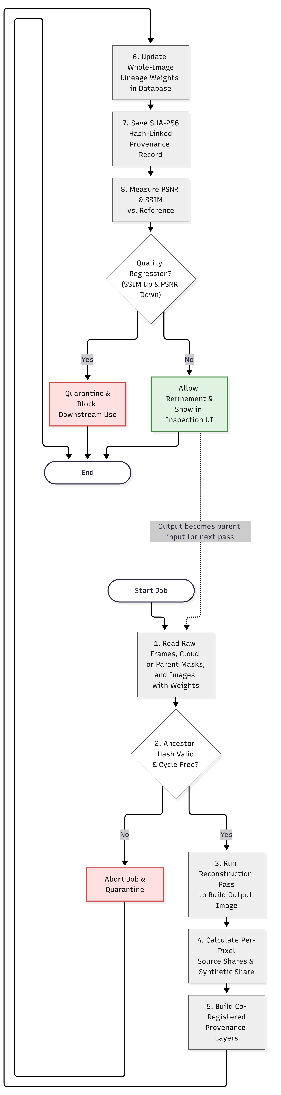
6.2 Algorithm Steps
- Read inputs. Load raw satellite frames with their cloud masks, or earlier reconstructed images, with normalized input weights (Section 6.4). On the Log Job page the analyst mixes raw frames and earlier reconstructed images, sets each input’s contribution weight and enters the algorithm parameters, which are stored as JSONB.
- Verify ancestry. Walk up the parent graph with a visited-node set. If a loop or a hash mismatch is found, abort the job and quarantine that branch (Section 6.8).
- Run the reconstruction pass. Execute the chosen algorithm (POCS, ESRGAN or ESRGAN_AGGRESSIVE) to produce the output image I.
- Calculate per-pixel shares. For every pixel, compute how much comes from each raw frame and how much is synthetic (Section 6.6).
- Build the provenance layers. Produce CLASS_MAP, UNCERTAINTY, SOURCE_INDEX and SYNTHETIC_SHARE, plus an ERROR_MAP against the ground-truth reference where one exists (Section 6.7).
- Update whole-image lineage. Compute the overall frame weights and the Generative Contamination Index (GCI), and cross-check the GCI against CLASS_MAP (Section 6.6).
- Save the hash-linked record. Combine the input and output digests, parameters and parent hashes into one signed SHA-256 record (Section 6.8).
- Check the quality gate. Measure PSNR and SSIM. If sharpness rose while signal fidelity fell, quarantine the image. Otherwise approve it for further refinement (Section 6.9).
6.3 Per-Pixel Provenance State
Raw satellite frames and cloud masks. The inputs are several optical or SAR captures of the same area, ℱ = {f₁, f₂, …, fₘ}. Each frame comes with a mask that says, pixel by pixel, how much of the ground is hidden:
mₖ(u,v) ∈ [0, 1] (0 = clear view of the ground, 1 = fully hidden)
Job inputs and weights. A job J at generation g takes a set of inputs, Inputs(J). Each input x is either a raw frame or a parent image from an earlier generation. Each gets a blending weight, and the weights add up to 1:
∑ₓ∈Inputs(J) w(x,J) = 1, w(x,J) ≥ 0
Algorithm generative factor. Each registered algorithm a has a calibrated factor rₐ that says how much new content it invents:
rₐ ∈ [0, 1] (rₐ = 0 for deterministic methods such as POCS; rₐ > 0 for generative methods such as ESRGAN)
6.4 Per-Pixel Provenance State
For every pixel (u,v) of an output image I, the system stores five values:
Pᵢ(u,v) = {Wᵢ(u,v), Sᵢ(u,v), Cᵢ(u,v), Uᵢ(u,v), Dᵢ(u,v)}
- Wᵢ(u,v) = [Wᵢ(u,v)[f₁], …, Wᵢ(u,v)[fₘ]]: the share of the pixel that came from each raw frame (SOURCE_WEIGHT).
- Sᵢ(u,v) ∈ [0, 1]: the synthetic share, i.e. the part that is interpolated or generated.
- Cᵢ(u,v) ∈ {OBSERVED, WEAK, SYNTHESIZED}: the pixel label (CLASS_MAP).
- Uᵢ(u,v) ∈ [0, 1]: the uncertainty (UNCERTAINTY).
- Dᵢ(u,v) ∈ {1, …, m, NONE}: the dominant contributing frame (SOURCE_INDEX).
6.4 Share Propagation and Conservation
Starting point (raw frame). A raw frame is “real” wherever the sky is clear and “missing” wherever it is cloudy:
W_fₖ(u,v)[fⱼ] = { 1 − mₖ(u,v), if j = k; 0, if j ≠ k }
S_fₖ(u,v) = mₖ(u,v)
One refinement pass. When job J produces image I using algorithm a, each pixel inherits the shares of its inputs, scaled down by how much the algorithm invents, and the invented part is added to the synthetic share:
Wᵢ(u,v)[f] = (1 − rₐ) ∑ₓ∈Inputs(J) w̃ᵤ,ᵥ(x,J) · Wₓ(u,v)[f]
Sᵢ(u,v) = (1 − rₐ) ∑ₓ∈Inputs(J) w̃ᵤ,ᵥ(x,J) · Sₓ(u,v) + rₐ
Here w̃ᵤ,ᵥ(x,J) is the weight w(x,J) re-normalized at that pixel, so inputs that are cloud-covered there count for less and the local weights add up to 1. If every input is hidden at a pixel and it is filled by interpolation, then Wᵢ(u,v)[f] = 0 for all f and Sᵢ(u,v) = 1.
Invariant I1: Per-Pixel Share Conservation. For every pixel and every generation g ≥ 1:
∑f∈ℱ Wᵢ(u,v)[f] + Sᵢ(u,v) = 1
Proof. For a raw frame, (1 − mₖ) + mₖ = 1. Assume every input x sums to 1 at (u,v). Then for the new image:
∑f Wᵢ + Sᵢ = (1 − rₐ) ∑ₓ w̃ · (∑f Wₓ + Sₓ) + rₐ
= (1 − rₐ) · 1 + rₐ = 1
By induction, this holds at every generation.
Whole-image lineage. The same rule gives image-level totals, which are cheap to query:
c(I)[f] = (1 − rₐ) ∑ₓ∈Inputs(J) w(x,J) · c(x)[f]
s(I) = (1 − rₐ) ∑ₓ∈Inputs(J) w(x,J) · s(x) + rₐ
For a raw frame, c(fₖ)[fₖ] = 1 − m̄ₖ and s(fₖ) = m̄ₖ, where m̄ₖ is the mean of its cloud mask. The GCI s(I) is cross-checked against the fraction of SYNTHESIZED pixels in CLASS_MAP.
Worked example (Fig. 3). Two cloud-free frames F1 and F2 feed Job 1 (deterministic, r = 0) with weights 0.4 and 0.6, producing Image 1. Image 1 then feeds Job 2 (generative, r = 0.3) with weight 1.0, producing Image 2:
Image 1:
c = {F1: 0.4, F2: 0.6}, s = 0
Image 2:
c(F1) = 0.7 × 0.4 = 0.28
c(F2) = 0.7 × 0.6 = 0.42
s = 0.7 × 0 + 0.3 = 0.30
Check: 0.28 + 0.42 + 0.30 = 1.00
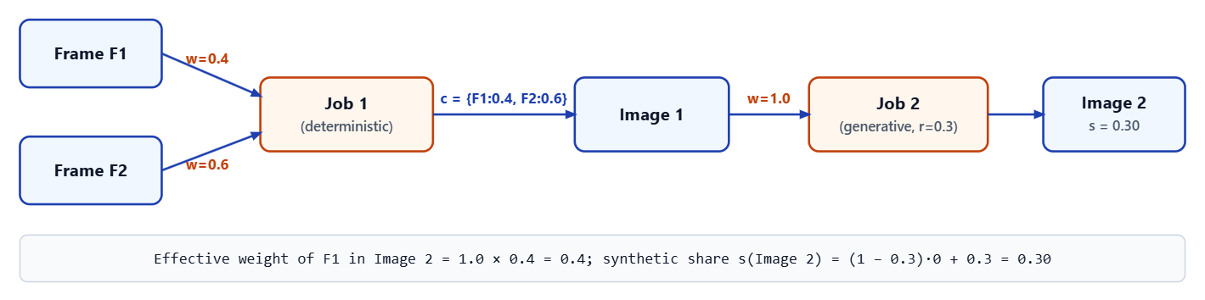
Fig. 2: Provenance DAG with example weights, propagated effective weights and synthetic share.

6.6 Pixel Classification, Source Index and Uncertainty
Each pixel is labelled from its synthetic share and its strongest real source. With thresholds 0 < θ_obs < θ_synth ≤ 1 (θ_obs = 0.20, θ_synth = 0.80) and a dominance threshold θ_dom: In the prototype θ_obs = 0.20, θ_dom = 0.30 and θ_synth = 0.80 (Fig. 16).
Cᵢ(u,v) = OBSERVED, if Sᵢ(u,v) ≤ θ_obs and max_f Wᵢ(u,v)[f] ≥ θ_dom
Cᵢ(u,v) = SYNTHESIZED, if Sᵢ(u,v) ≥ θ_synth
Cᵢ(u,v) = WEAK, otherwise
The dominant frame is the one with the largest share, and is NONE when the pixel is synthesized or has no real source:
Dᵢ(u,v) = NONE, if Cᵢ(u,v) = SYNTHESIZED or max_f Wᵢ(u,v)[f] = 0
Dᵢ(u,v) = arg max over f ∈ ℱ of Wᵢ(u,v)[f], otherwise
Uncertainty rises with the synthetic share and with disagreement between frames:
Uᵢ(u,v) = min {1, Sᵢ(u,v) + (1 − Sᵢ(u,v)) · σ²_inter(u,v)}
where σ²_inter(u,v) is the normalized inter-frame variance at that pixel.
Invariant I2: Non-Decreasing Synthetic Share. In a single-input pass, the synthetic share can only grow:
S_child(u,v) − S_parent(u,v) = rₐ · (1 − S_parent(u,v)) ≥ 0
So a synthesized pixel can never become OBSERVED again unless new, unoccluded sensor frames are fused in.
6.7 Hash-Linked Record and Replay Verification
Every job is stored as a node in a directed acyclic graph. Its record hash covers everything that defines the result, and is signed with the analyst’s key:
H_J = SHA-256(CanonicalSerialize(Inputs(J), {H_parent}, a, params, seed, environment, SHA-256(I), SHA-256(Pᵢ)))
σ_J = Ed25519.Sign(K_analyst, H_J)
Changing any past weight, parameter or parent link changes H_J and breaks every descendant. A job is allowed to start only if all its ancestors verify:
G_hash(I) = 1, if every ancestor hash and signature matches its recomputed value; otherwise, G_hash(I) = 0.
Replay verification re-runs a recorded job. Deterministic CPU algorithms must reproduce the output bit-exactly. Generative GPU algorithms are checked by perceptual-hash comparison and RMSE within set tolerances.
6.8 Quality-Regression Gate
A generative pass can make an image look sharper (higher SSIM) while making it less faithful to the real signal (lower PSNR). The gate looks for exactly that pattern:
A(I) = 1, if both of the following conditions hold:
SSIM(I) − SSIM(I_parent) > τ_SSIM
PSNR(I) − PSNR(I_parent) < −τ_PSNR
Otherwise, A(I) = 0.
Invariant I3: Tamper-Evident Descendant Invalidation and Gating. The pipeline action is:
PipelineAction(I) = QUARANTINE_BLOCK, if G_hash(I) = 0 or A(I) = 1
PipelineAction(I) = ALLOW_REFINEMENT, otherwise.
PSNR and SSIM are measured against a reference image (the ground-truth layer in the prototype). When a job has several parents, the comparison is made against each parent and the job is flagged if any comparison trips.

7. Proposed Design and Framework
The framework implements the method of Section 6 as a layered web system, with the layers shown in Fig. 3. Each layer has one responsibility, and provenance is stored where it cannot be silently edited. The analyst console has five pages: Dashboard, Log Job, My Jobs, Lineage and Frames (Figs. 4–8).
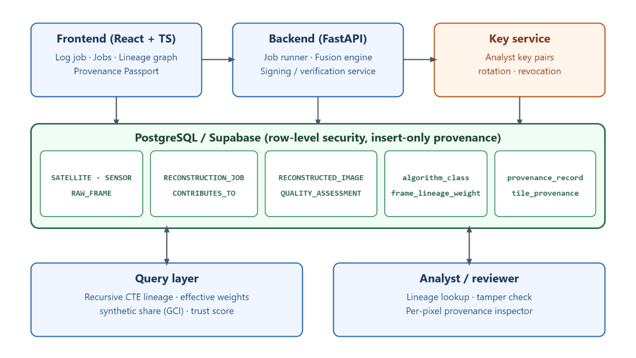
Fig. 3: System architecture (frontend, backend, database, key service, query layer).

7.1 Functional Modules
Each module is described by what it takes in and what it passes on.
Module | Receives | Produces | Runs in
Ingestion and cloud-mask preprocessor | Raw frames, sensor details, cloud masks | Frames with starting shares (W, S) | Backend
Reconstruction and layer generator | Frames or parent images, algorithm choice, weights | Output image with SOURCE_WEIGHT, CLASS_MAP, UNCERTAINTY, SOURCE_INDEX, SYNTHETIC_SHARE, ERROR_MAP | Backend (fusion engine)
DAG share propagation engine | Job inputs and parent records | Per-pixel shares and whole-image lineage weights | Backend and database
Hash-DAG and replay verification unit | Job record, signing key | Signed record, replay verdict | Backend and key service
Quality-regression controller | Output and parent metrics, ancestry result | ALLOW or QUARANTINE decision | Backend
Analyst console and frame manager | Frame selections, input weights, algorithm parameters (JSONB) | Job log, lineage graph, Provenance Inspector in pixel and tile modes | Frontend

7.2 Data Model
The database groups its tables by what they hold:
- Acquisition data (SATELLITE, SENSOR, RAW_FRAME): where each raw frame came from.
- Processing graph (RECONSTRUCTION_JOB, CONTRIBUTES_TO): each job and the weighted links from inputs to output, which together form the DAG.
- Results (RECONSTRUCTED_IMAGE, QUALITY_ASSESSMENT): the output images and their PSNR and SSIM values.
- Provenance (algorithm_class, frame_lineage_weight, provenance_record, tile_provenance): the generative factor of each algorithm, the whole-image frame weights, the signed hash records and the per-pixel provenance layers.
7.3 Integrity and Security Design
Provenance tables are insert-only, so a past record cannot be updated or deleted through normal use. Row-level security restricts each analyst to permitted rows. Signing keys are held in a separate key service, apart from the database, and the key service supports rotation and revocation, so a compromised key can be retired without invalidating older records. A job that fails the hash or quality gate is marked FAILED and shown as QUARANTINED in the lineage graph (Figs. 6, 7), and the Frames page shows how many jobs depend on each frame or product (Fig. 8).
7.4 Query Design
Lineage questions are answered with recursive queries over the job graph. These return the effective frame weights, the synthetic share (GCI) and a trust score for any image, without recomputing pixels.
7.5 Parameter Correlation
The input weights and the generative factor together determine the shares. The shares determine the labels, the dominant source and the uncertainty. The shares and inputs together determine the record hash. The ancestry result and the quality flag together determine the pipeline action.
7.6 Framework Characteristics
The framework is traceable (every pixel keeps its source shares), conserving (shares always sum to 1), monotonic in synthetic content, tamper-evident, and self-gating.

8.Experimental validation results
Prototype Implementation: We built a full-stack web prototype of OrbitalTrace (frontend, backend, database, key service and query layer; Fig. 3, with screenshots in Figs. 4–8) and ran it on ESA Sentinel-2A 10 m optical telemetry. Four raw frames (IDs #11–#14, with 5%, 20%, 40% and 60% cloud cover) were ingested (Fig. 8) and fed the first fusion pass. The dashboard lists the six resulting jobs, #7–#12 (Fig. 4).
Per-Pixel Provenance Generation: Each reconstruction job produced per-pixel layers that can be viewed in the Provenance Inspector in pixel and tile modes (Figs. 13–19): IMAGE, GROUND_TRUTH, ERROR_MAP, CLASS_MAP, UNCERTAINTY, SOURCE_INDEX and SYNTHETIC_SHARE. The CLASS_MAP uses thresholds θ_obs = 0.20, θ_dom = 0.30 and θ_synth = 0.80 (Fig. 16). Hovering over a pixel reads out its coordinate, class, uncertainty, synthetic share, dominant source and absolute error; for example, a pixel in the filled region of Image #10 reads Synthesized, uncertainty 0.95, synthetic share 0.95, dominant source none (filled by interpolation), absolute error 0.831 (Fig. 19).
Multi-Generation Propagation: The pipeline executed a refinement chain with a diamond topology (Fig. 7): Job #7 fused the four raw frames at 25% each into Image #6; Jobs #8 and #9 produced two parallel POCS branches (Images #7 and #8); Job #10 merged the branches at 50% each into Image #9; and an ESRGAN pass (rₐ = 0.35) then produced Image #10. Propagated weights and synthetic shares satisfied the conservation invariant I₁ (Σ W + S = 1): the deviation was exactly 0 across the linear POCS passes and at most 9.80 × 10⁻⁴ for the generative pass, within the 10⁻³ bound (Fig. 9).
Synthetic Share Behaviour: The POCS passes (rₐ = 0) stayed low, at most 5.4% (Fig. 10). Applying the generative ESRGAN pass (rₐ = 0.35) raised the synthetic share to 35.0% (GCI = 0.3500; Figs. 10, 13), consistent with invariant I₂. After this pass no pixel of Image #10 qualified as OBSERVED, because the synthetic share (≥ 0.35) exceeds θ_obs = 0.20; the CLASS_MAP is almost entirely WEAK with two SYNTHESIZED regions (Fig. 16).
Quality Metrics: Against the ground-truth layer (Figs. 14–15), the stored metrics were: Image #6 13.31 dB / 0.6870, Image #7 14.99 dB / 0.7420, Image #8 12.47 dB / 0.6810 and merged Image #9 13.89 dB / 0.7110 (Figs. 7, 10). The ESRGAN output, Image #10, scored lower at 8.65 dB / 0.5620 (Fig. 13), so on this data the generative pass did not improve fidelity. The error map (Fig. 15) shows where the error is concentrated.
Hash-DAG Integrity: Every job record is hashed with SHA-256 and signed with Ed25519. In a simulated tamper test, a mutated digest injected into ancestor Job #8 failed its hash and signature checks (TAMPER_DETECTED), and the descendant merge Job #10 returned G_hash = 0 while its other parent, Job #9, still verified. The fault was isolated to Job #8 and the pipeline gate enforced QUARANTINE_BLOCK on the descendant (Fig. 11).
Quality-Regression Gate: We evaluated the anomaly gate on Job #12 (ESRGAN_AGGRESSIVE, refining Image #9) with τ_SSIM = 0.02 and τ_PSNR = 1.50 dB. The gate logged ΔSSIM = +0.0220 and ΔPSNR = −2.50 dB, so A(I) = 1, and Job #12 was marked FAILED and quarantined with a full audit-log entry (Figs. 7, 12). [CONFIRM: the stored metrics of Image #9 (13.89 dB / 0.7110) and Image #11 (12.49 dB / 0.7640) differ by +0.0530 and −1.40 dB, not by the logged deltas; re-run the gate and recapture Fig. 12 before filing.]
8.1 Prototype screenshots
Figs. 4–19 show the running OrbitalTrace prototype: the analyst workflow (Figs. 4–8), the invariant and security checks (Figs. 9–12) and the Per-Pixel Provenance Inspector layers (Figs. 13–19).
  Fig. 4: Dashboard: job counts, recent reconstruction jobs and analyst workflows. | 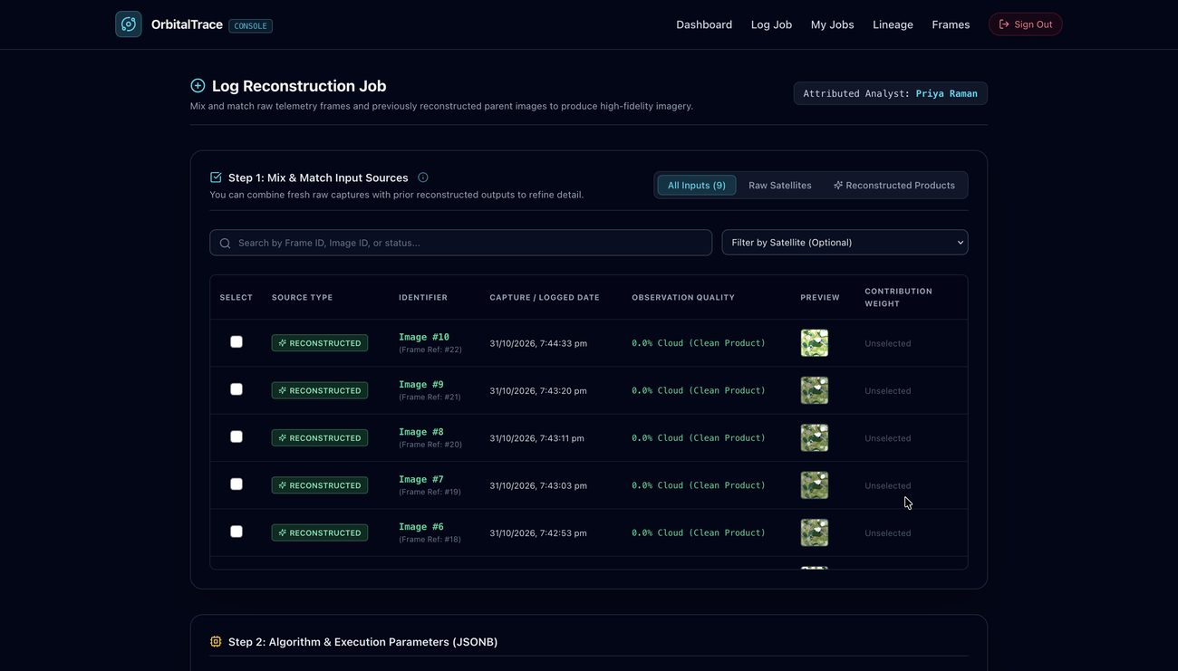  Fig. 5: Log Reconstruction Job: mix raw frames and earlier output images as inputs, then set weights.
  Fig. 6: My Reconstruction Jobs: job status and generated output-image metadata (PSNR, SSIM, synthetic fraction, uncertainty). | 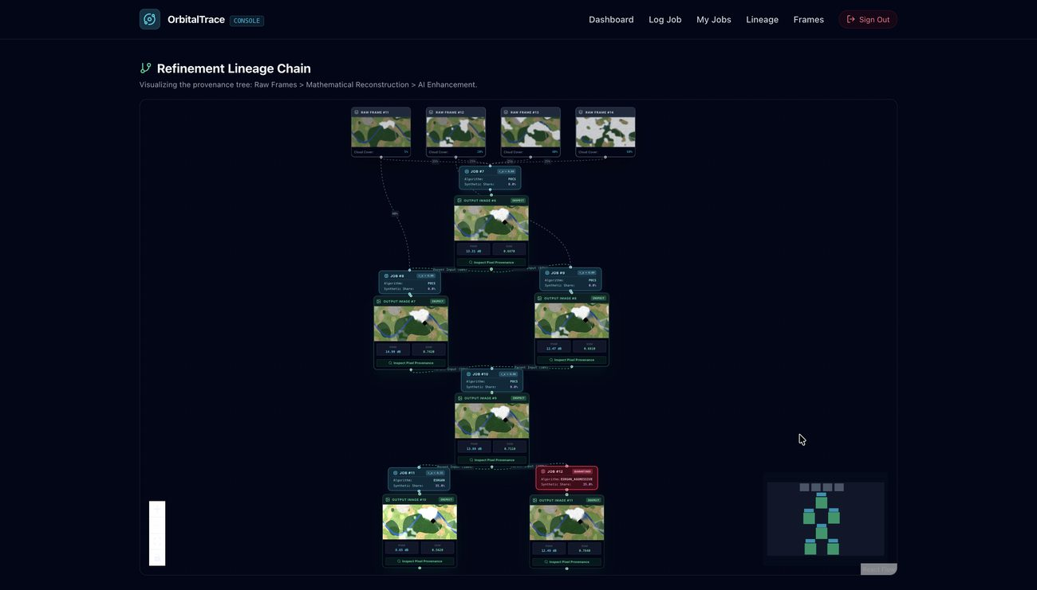  Fig. 7: Refinement Lineage Chain: raw frames to POCS and ESRGAN passes, with per-edge weights and a quarantined job.
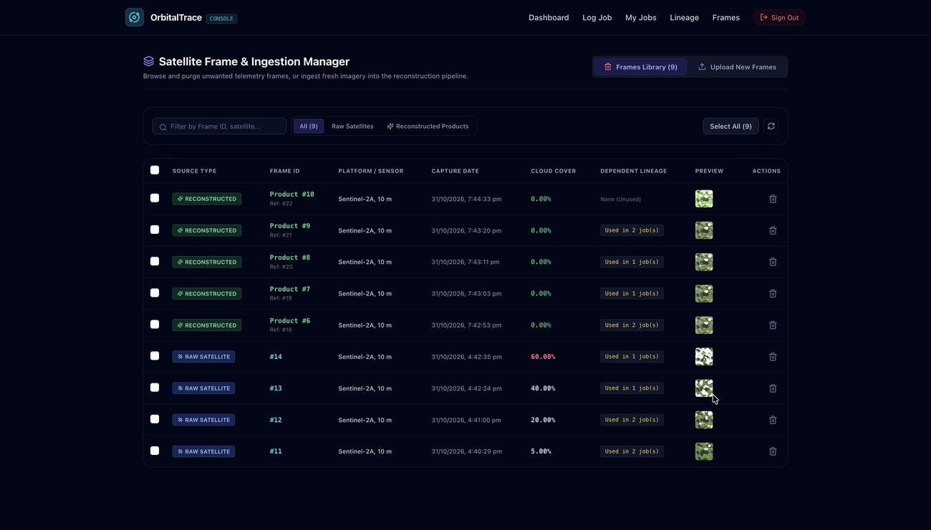  Fig. 8: Frame and Ingestion Manager: raw frames with cloud cover and dependent lineage. | 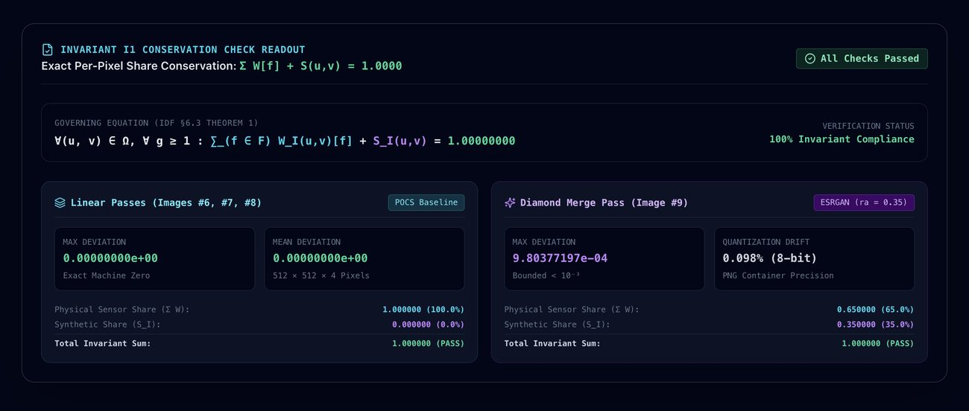  Fig. 9: Invariant I1: per-pixel share conservation check (all checks passed).
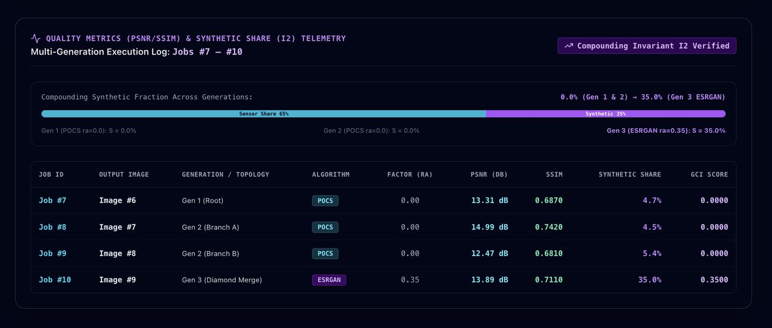  Fig. 10: Invariant I2: synthetic share compounding across generations, with PSNR, SSIM and GCI. | 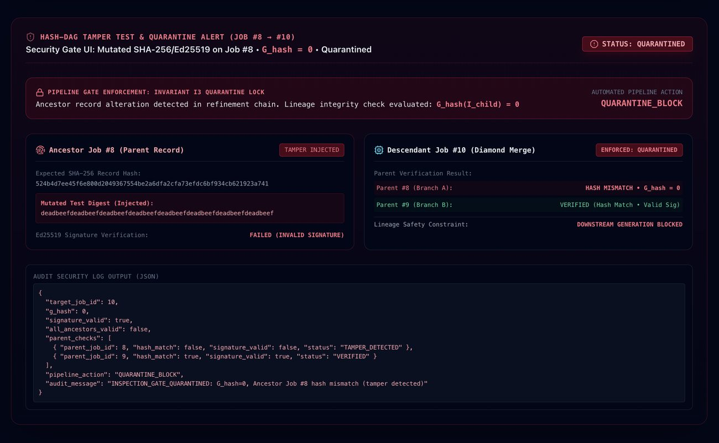  Fig. 11: Hash-DAG tamper test: altered ancestor record detected and descendant quarantined.
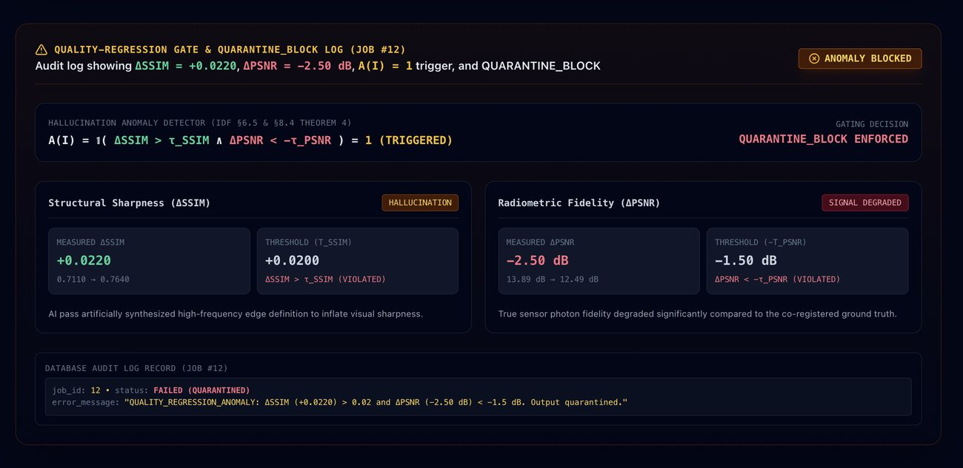  Fig. 12: Quality-regression gate: SSIM up and PSNR down triggers QUARANTINE_BLOCK. | 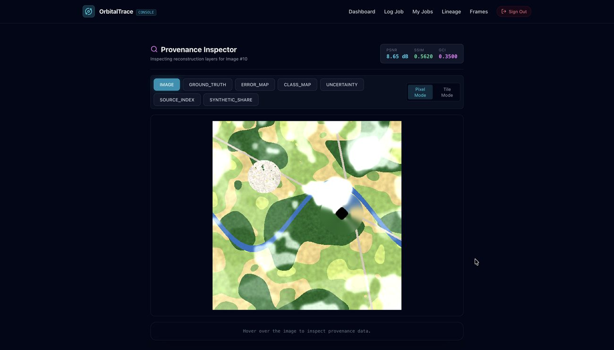  Fig. 13: Provenance Inspector: IMAGE layer.
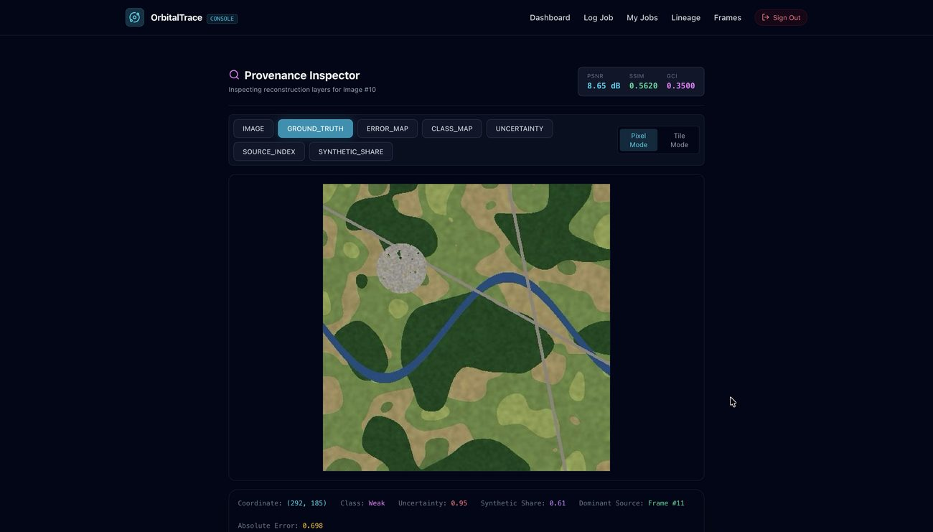  Fig. 14: Provenance Inspector: GROUND_TRUTH layer. | 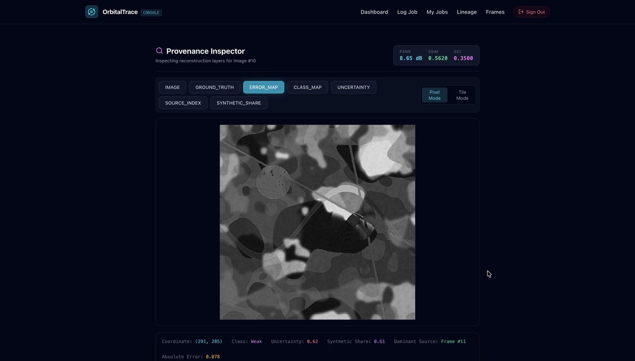  Fig. 15: Provenance Inspector: ERROR_MAP layer.
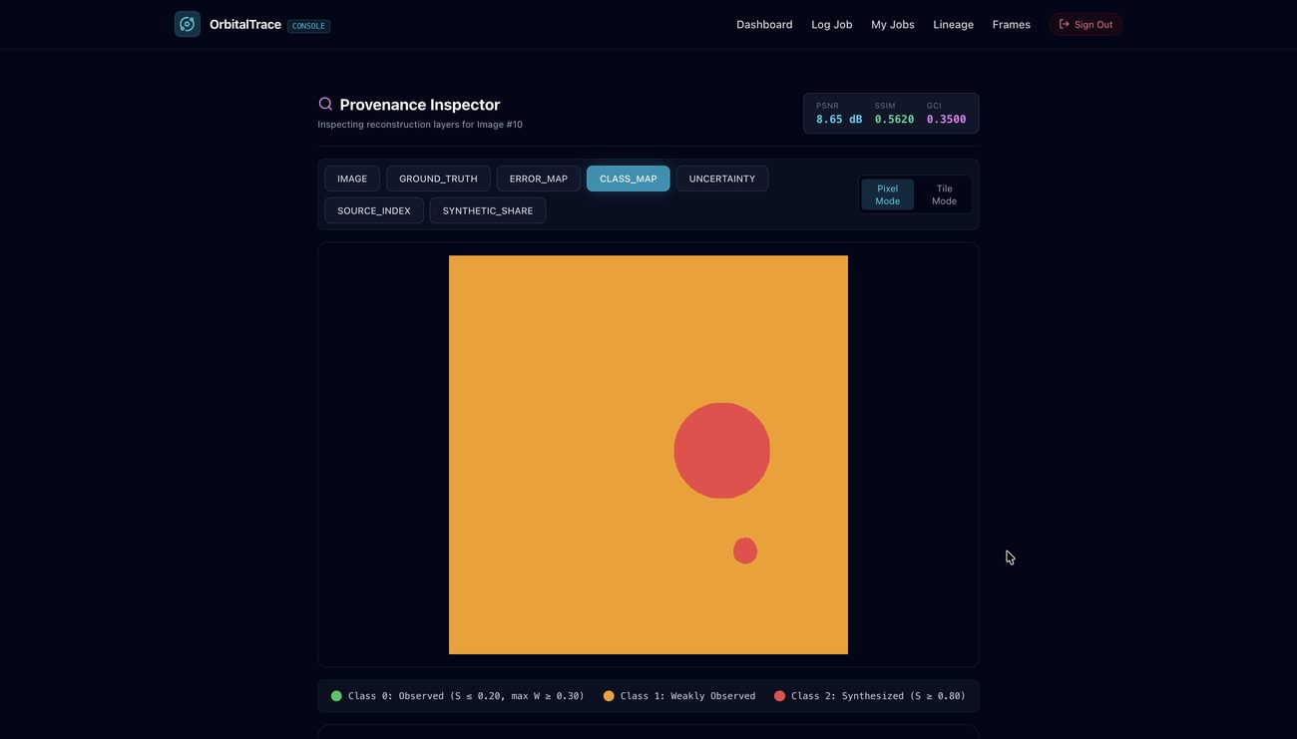  Fig. 16: Provenance Inspector: CLASS_MAP layer (observed, weakly observed, synthesized). | 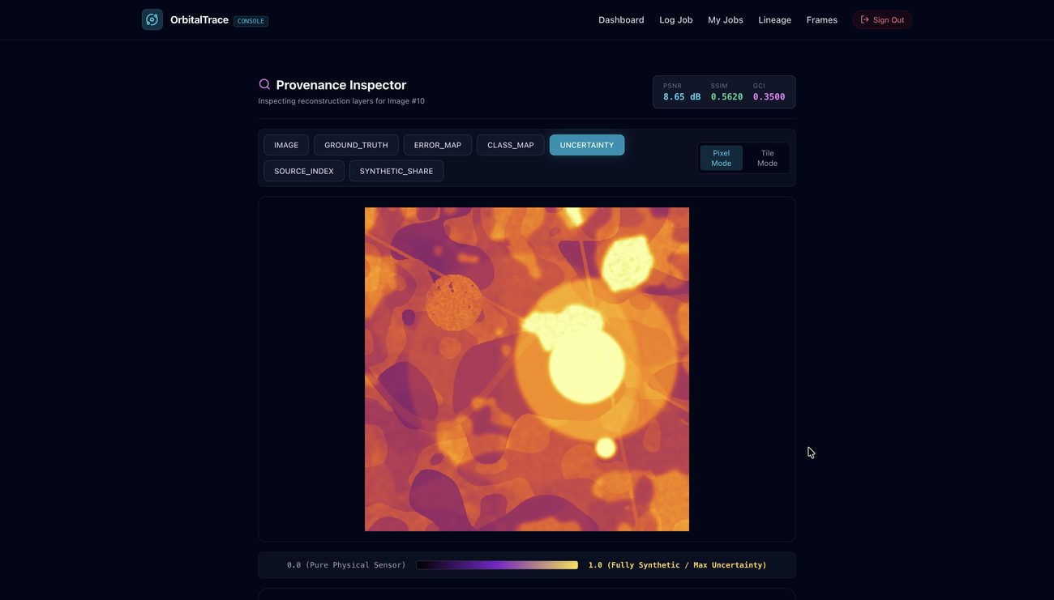  Fig. 17: Provenance Inspector: UNCERTAINTY layer.
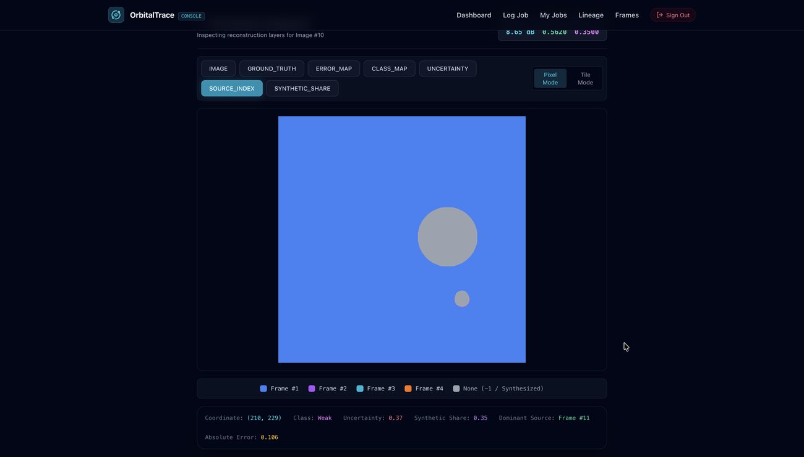  Fig. 18: Provenance Inspector: SOURCE_INDEX layer (dominant source frame). | 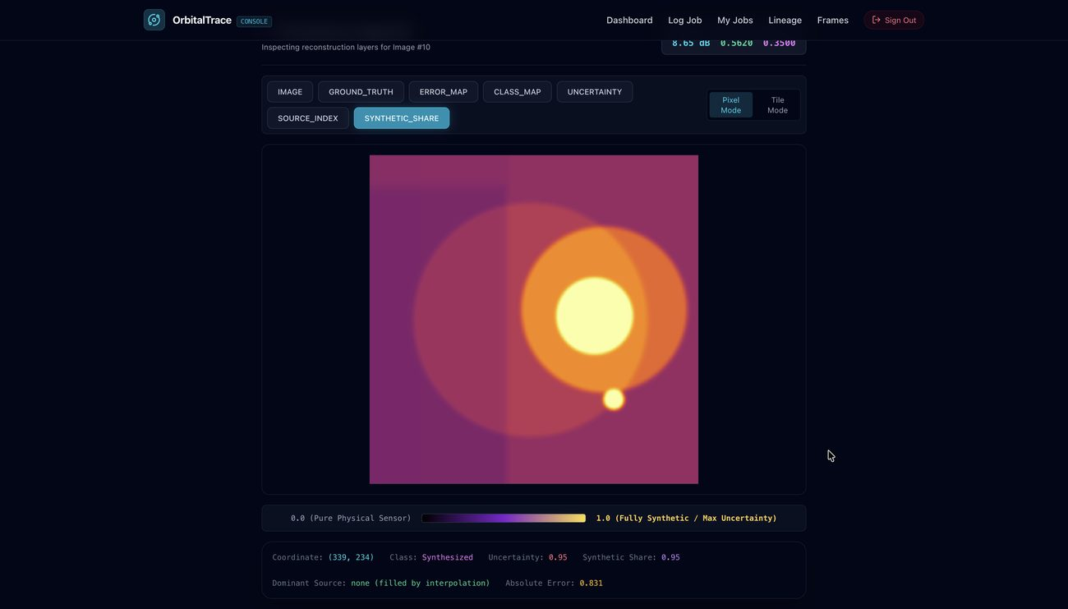  Fig. 19: Provenance Inspector: SYNTHETIC_SHARE layer.

9. EXPECTED OUTPUT AND OUTCOME OF THE SYSTEM
• Per-pixel traceability: Every single pixel in a multi-generation reconstructed satellite image stores a vector (SOURCE_WEIGHT) which stores the exact fractional contribution of the frames used to generate the image. This vector stores what share of the pixel came from each of the raw frames used, allowing the pixel to be traced all the way back to its sources.
• Synthetic content tracking: Separates the real sensor observed signal from the interpolated or generatively synthesised content using an inherited synthetic share channel SI(u,v) and a compounding Generative Contamination Index (GCI).
• Pixel provenance viewer: Analysts get an interactive Per-Pixel Provenance Inspector, in pixel and tile modes, with seven views: IMAGE, GROUND_TRUTH, ERROR_MAP, a 3-state CLASS_MAP (OBSERVED, WEAK, SYNTHESIZED), UNCERTAINTY on a 0 to 1 scale, SOURCE_INDEX and SYNTHETIC_SHARE.
• Tamper detection: Identifies any post-hoc database modification to historical weights, parent links, metrics, or images that are previously stored in the refinement DAG using SHA-256 parent hash chaining.
• Hallucination blocking: Where SSIM rises and PSNR drops the system flags it and blocks any image that is unverified or anomalous from the later downstream refinement jobs to prevent compounding generative hallucinations.
10. What aspect(s) of the invention need(s) protection?
- The raw satellite frame contribution weights (SOURCE_WEIGHT) and the inherited synthetic share channel (SI(u,v)) are composed over consecutive image refinement passes in a directed acyclic graph (DAG) by the multi-generation per-pixel provenance propagation mechanism, which is configured for this purpose.
- The compounding Generative Contamination Index (GCI) propagation and spatial cross-validation mechanism making use of tuned algorithm generative factors ra ∈ [0,1] verified verified against spatial proportion of SYNTHESISED pixels in the CLASS_MAP.
- The cycle-guarded, hash-linked DAG provenance record structure encapsulating things like input image digests, output provenance layer digests, algorithm parameters, and parent record hashes even when processing is split into many paths or when several paths come back together
- Replay verification mechanism with two modes: bit-exact cryptographic hash matching for deterministic CPU algorithms and bounded perceptual-hash/pixel-error tolerance matching for GPU generative models.
- The automatic pipeline gate and quality-regression hallucination anomaly detector set up to quarantine reconstructed images when ancestry verification is unsuccessful or when SSIM rises while PSNR falls below a predetermined threshold.
What is Technology readiness level of your invention?
Research |  |  | Development |  |  | Deployment
TRL 1 | TRL 2 | TRL 3 | TRL 4 | TRL 5 | TRL 6 | TRL 7 | TRL 8 | TRL 9
Basic Principles observed | Technology concept formulated | Experimental proof of concept | Technology validated in a lab | Technology validated in a relevant environment | Technology demonstrated in a relevant environment | System prototype demonstration in an operational environment | System complete and qualified | Actual system proven in an operational environment
✓ | ✓ | ✓

----------------------END OF THE DOCUMENT-----------------------------

